04/05 March 2023
Second Sunday of Lent
Gathering Hymn: “Lord, Help Us Walk Your Servant Way”
Text: Herman Steumpfle, ©GIA Publications, Inc.
Tune: MORNING SONG
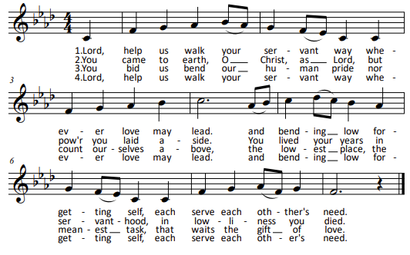

CONFITEOR
I confess to almighty God
and to you, my brothers and sisters,
that I have greatly sinned
in my thoughts and in my words,
in what I have done,
and in what I have failed to do;
through my fault, through my fault,
through my most grievous fault;
therefore I ask blessed Mary ever-Virgin,
all the Angels and Saints,
and you, my brothers and sisters,
to pray for me to the Lord our God.

“Kyrie” by Marty Haugen ©GIA Publications, Inc.
REFRAIN:
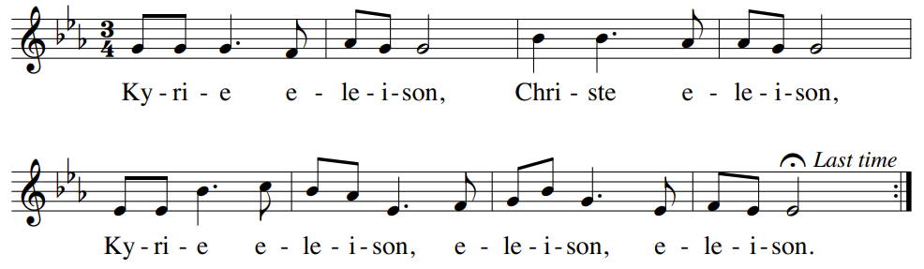

Liturgy of the Word
A reading from the Book of Genesis (12:1-4a)
The LORD said to Abram: "Go forth from the land of your kinsfolk and from your father's house to a land that I will show you. “I will make of you a great nation, and I will bless you; I will make your name great, so that you will be a blessing. I will bless those who bless you and curse those who curse you. All the communities of the earth shall find blessing in you."

Responsorial Psalm:
“Psalm 33—Let Your Mercy Be on Us”
by Marty Haugen © GIA Publications, Inc.
Refrain: cantor, then all: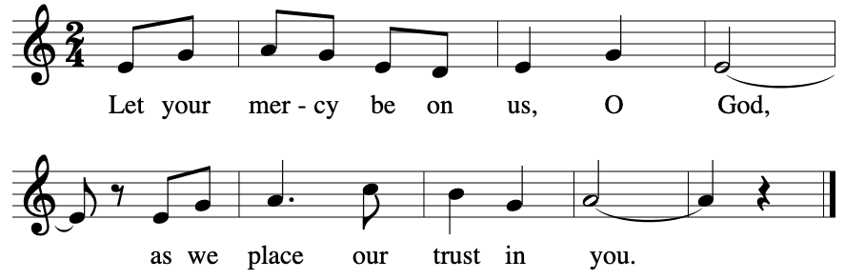
A reading from the second letter of Timothy (1:8b-10)
Beloved: Bear your share of hardship for the gospel with the strength that comes from God. He saved us and called us to a holy life, not according to our works but according to his own design and the grace bestowed on us in Christ Jesus before time began, but now made manifest through the appearance of our savior Christ Jesus, who destroyed death and brought life and immortality to light through the gospel.

Lenten Gospel Acclamation based on Wondrous Love
Arranged by Stephen Pishner
REFRAIN (cantor, then all):
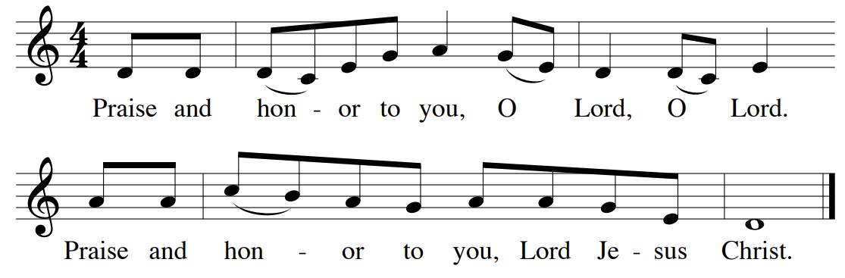

Verse: From the shining cloud the Father's voice is heard:
This is my beloved Son, hear him.

A reading from the Holy Gospel according to Matthew (17:1-9)
Jesus took Peter, James, and John his brother, and led them up a high mountain by themselves. And he was transfigured before them; his face shone like the sun and his clothes became white as light.

HOMILY

APOSTLE’S CREED
I believe in God,
the Father almighty,
Creator of heaven and earth,
and in Jesus Christ, his only Son, our Lord,
who was conceived by the Holy Spirit,
born of the Virgin Mary,
suffered under Pontius Pilate,
was crucified, died and was buried;
he descended into hell;
on the third day he rose again from the dead;
he ascended into heaven,
and is seated at the right hand of God the Father almighty;
from there he will come to judge the living and the dead.
I believe in the Holy Spirit,
the holy catholic Church,
the communion of saints,
the forgiveness of sins,
the resurrection of the body,
and life everlasting. Amen.

Sung Response for Intercessions: “O God, Hear Us”
by Bob Hurd
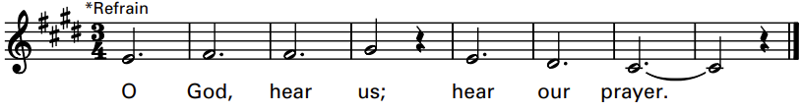
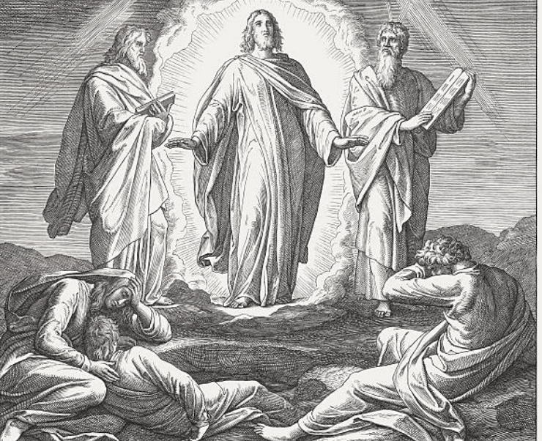
Liturgy of the Eucharist
Preparation of the Gifts: “Transform Us”
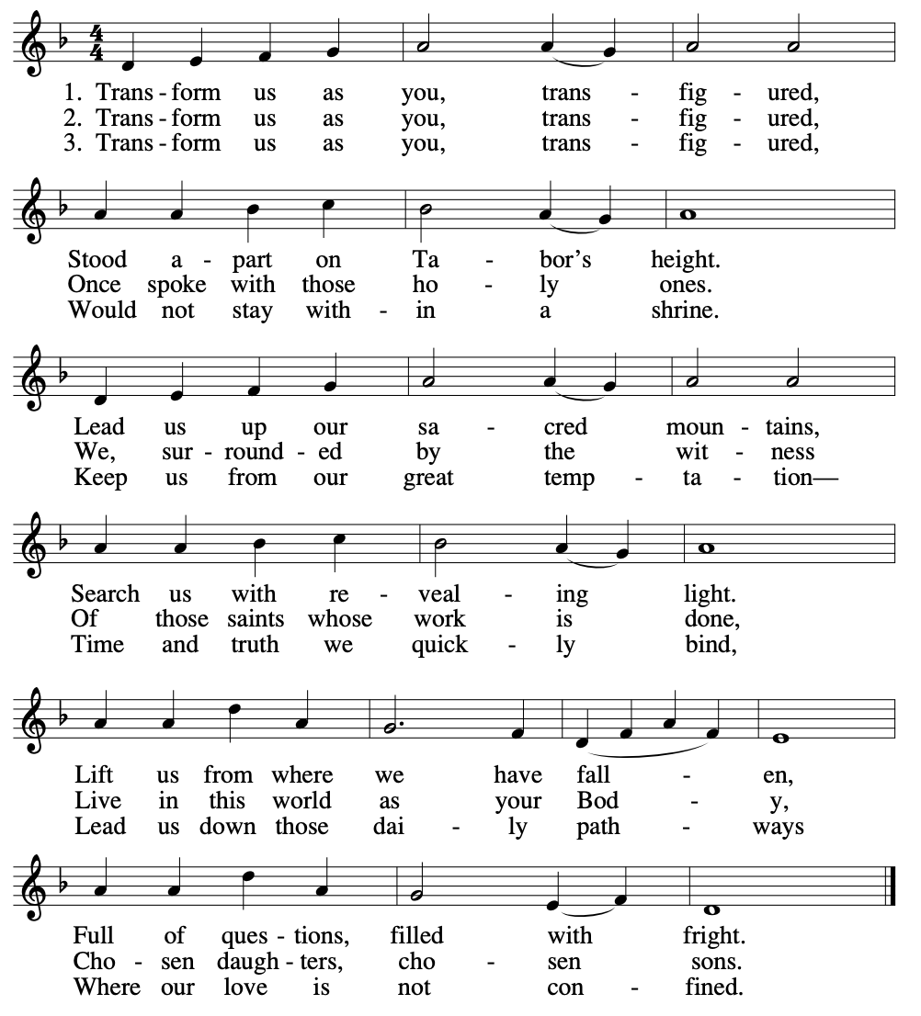
Eucharistic Acclamations and Lamb of God: Mass of Creation
by Marty Haugen ©1984 GIA Publications, Inc.
HOLY:
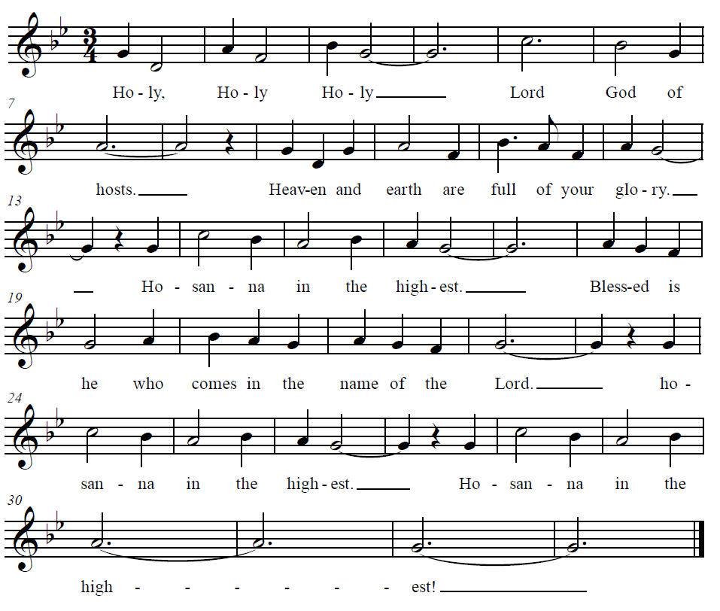
MEMORIAL ACCLAMATION:
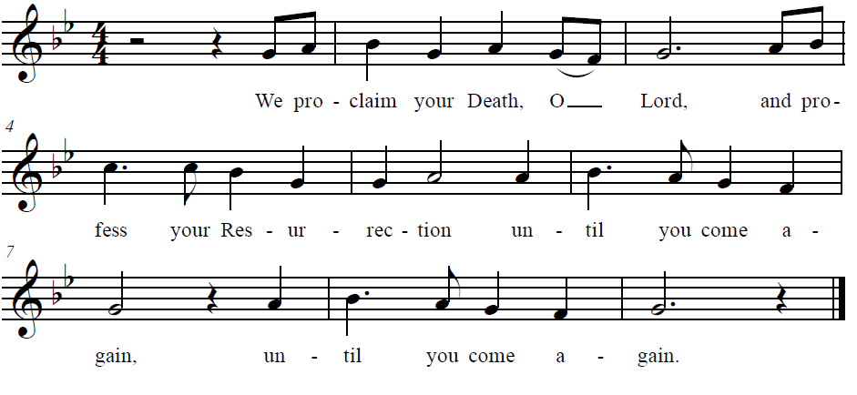
AMEN:
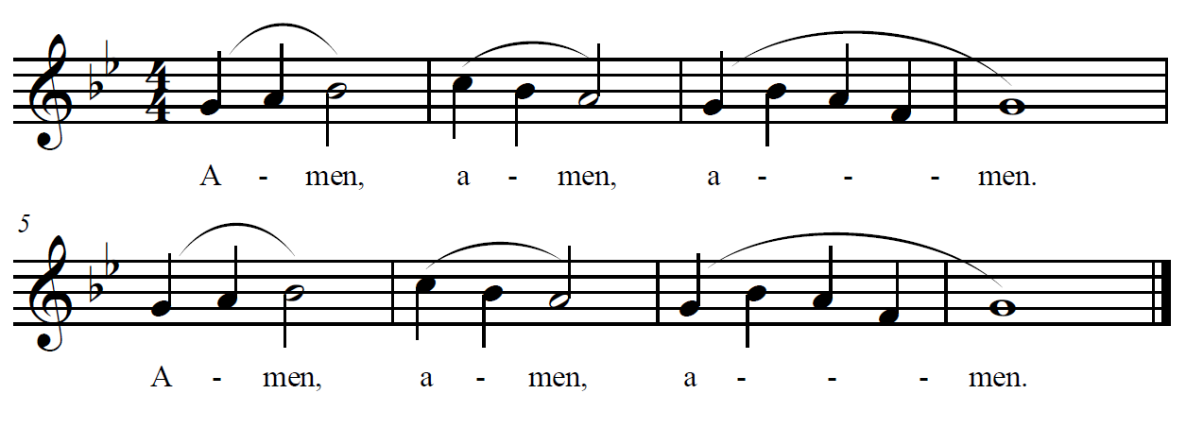
The Lord’s Prayer

Sign of Peace
Lamb of God from Mass of Creation

Music for the Communion Procession:
“Awake, O Sleeper” by Marty Haugen

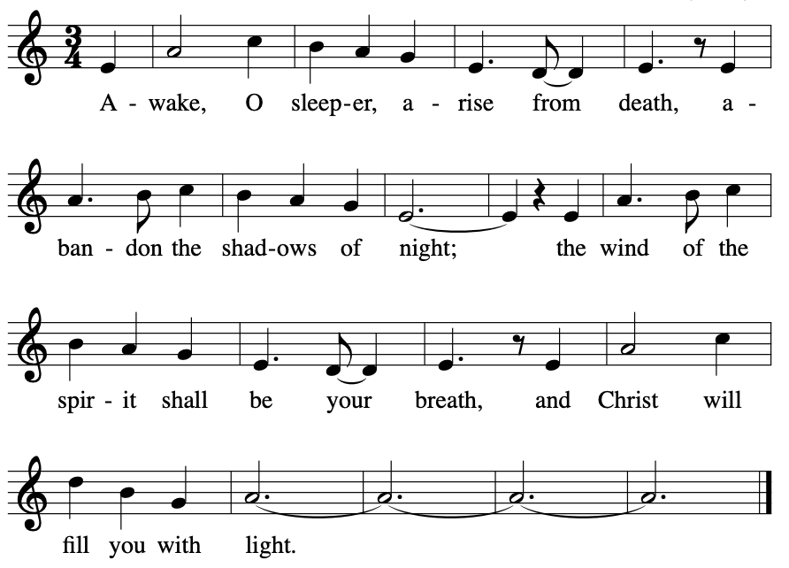

Recessional: “What Wondrous Love Is This?”
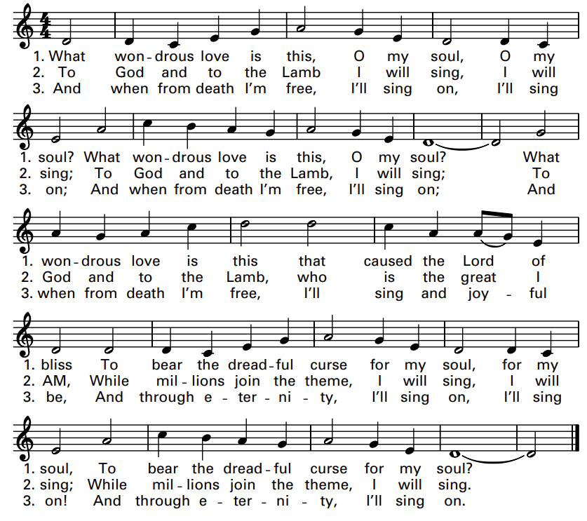
Text: 12 9 12 12 9; anon.; first appeared in A General Selection of the Newest and Most Admired Hymns and Spiritual Songs, 1811, adapt. Music: William Walker’s The Southern Harmony, 1835.

LENTEN SOUP AND SPEAKER SERIES AT NEWMAN
Soup and Sustenance for the Soul
This Friday, March 10 – Lower Level
Soup @ 5:30pm | Parishioner Mike Kreiling, Speaker @ 6:00 – 7:00pm
“Rise: My Journey through Grief to Growth”
Sign up at Newman or call the office to get on the list.

LENTEN STATIONS OF THE CROSS AND SOUP
AT BLESSED SACRAMENT
Tuesday evenings @ 5:30 PM in the Church; Soup to follow in the Parish Hall (Parishioners are also welcome to attend the BS School Stations of the Cross on Friday afternoons at 2:40 PM.)

