10/11 September 2022
24th Sunday in Ordinary Time (Welcome Back Sunday!)
Processional: “Gather Your People”
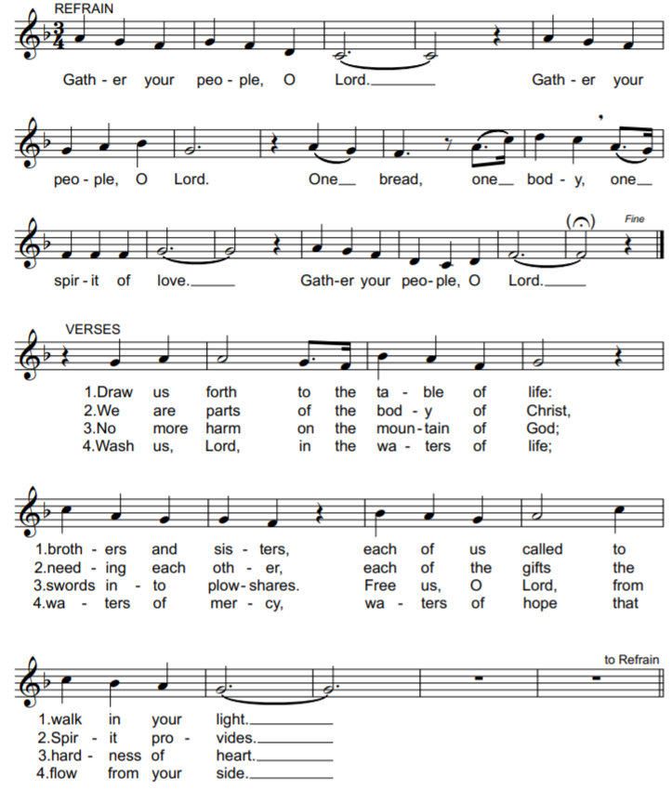

“Penitential Act” from Mass of St. Frances Cabrini
(spoken)

“Glory to God” from Mass of St. Frances Cabrini
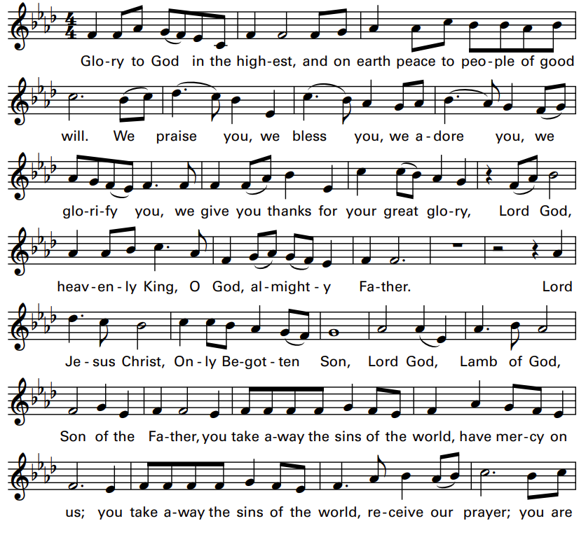
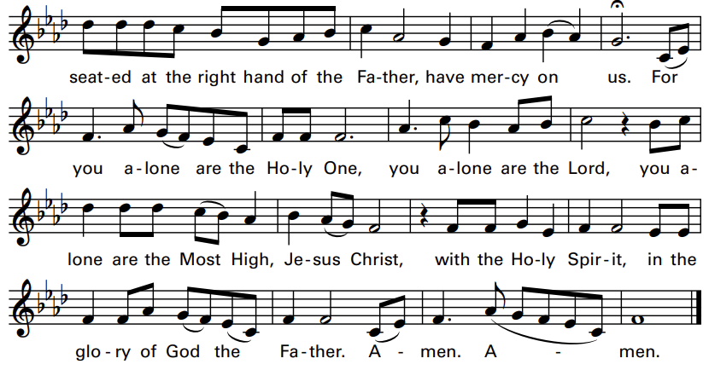

Liturgy of the Word
(Please be seated.)

A reading from the Book of Exodus (32:7-11, 13-14)
But Moses implored the LORD, his God, saying, "Why, O LORD, should your wrath blaze up against your own people, whom you brought out of the land of Egypt
with such great power and with so strong a hand? Remember your servants Abraham, Isaac, and Israel, and how you swore to them by your own self, saying, 'I will make your descendants as numerous as the stars in the sky; and all this land that I promised, I will give your descendants as their perpetual heritage.'"

Responsorial Psalm:
“Psalm 51 – I Will Rise and Go to My Father”
by Michel Guimont ©GIA Publications, Inc.
REFRAIN (Cantor, then ALL):
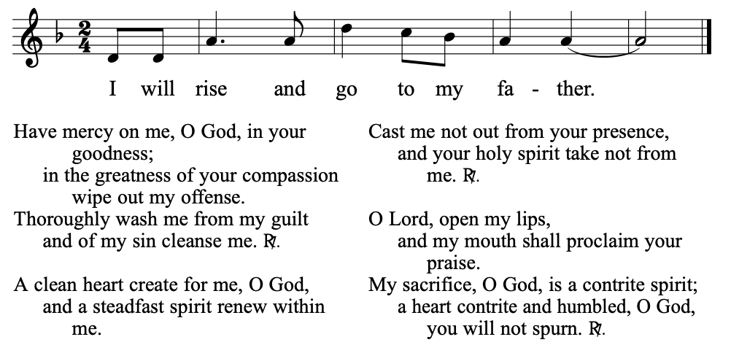

A reading from first letter of Paul to Timothy (1:12-17)
But for that reason, I was mercifully treated, so that in me, as the foremost, Christ Jesus might display all his patience as an example for those who would come to believe in him for everlasting life.

Gospel Acclamation: from Mass of St. Frances Cabrini
Refrain (Cantor, then ALL):
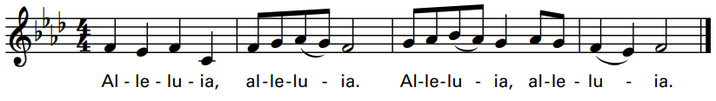
Verse: God was reconciling the world to himself in Christ,
and entrusting to us the message of reconciliation.

A reading from the Gospel of Luke (15:1-32)
His son said to him, ‘Father, I have sinned against heaven and against you; I no longer deserve to be called your son.’ But his father ordered his servants, ‘Quickly bring the finest robe and put it on him; put a ring on his finger and sandals on his feet. Take the fattened calf and slaughter it. Then let us celebrate with a feast, because this son of mine was dead, and has come to life again; he was lost and has been found.’

HOMILY
Nicene Creed
I believe in one God, the Father almighty,
Maker of heaven and earth,
of all things visible and invisible.
I believe in one Lord Jesus Christ, the Only Begotten
Son of God, born of the Father before all ages.
God from God, Light from Light, true God from true God,
begotten, not made,
consubstantial with the Father;
through him all things were made.
For us men and for our salvation he came down from heaven,
[Bow] and by the Holy Spirit was incarnate of the Virgin Mary,
and became man.
For our sake he was crucified under Pontius Pilate,
he suffered death and was buried,
and rose again on the third day
in accordance with the Scriptures.
He ascended into heaven and is seated
at the right hand of the Father.
He will come again in glory to judge the living and the dead
and his kingdom will have no end.
I believe in the Holy Spirit, the Lord, the giver of life,
who proceeds from the Father and the Son,
who with the Father and the Son is adored and glorified,
who has spoken through the prophets.
I believe in one holy, catholic and apostolic Church.
I confess one baptism for the forgiveness of sins and
I look forward to the resurrection of the dead and
the life of the world to come. Amen.

GENERAL INTERCESSIONS
Liturgy of the Eucharist
Preparation of the Gifts: “Lead, Kindly Light”
by Steven Warner
REFRAIN (Cantor, then ALL):
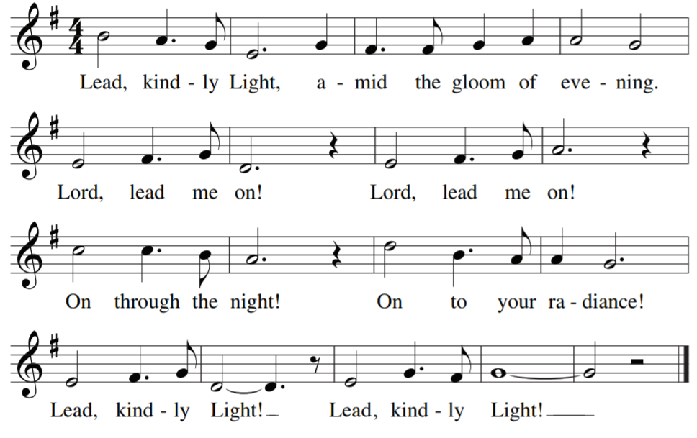
Eucharistic Acclamations: from Mass of St. Frances Cabrini
HOLY:
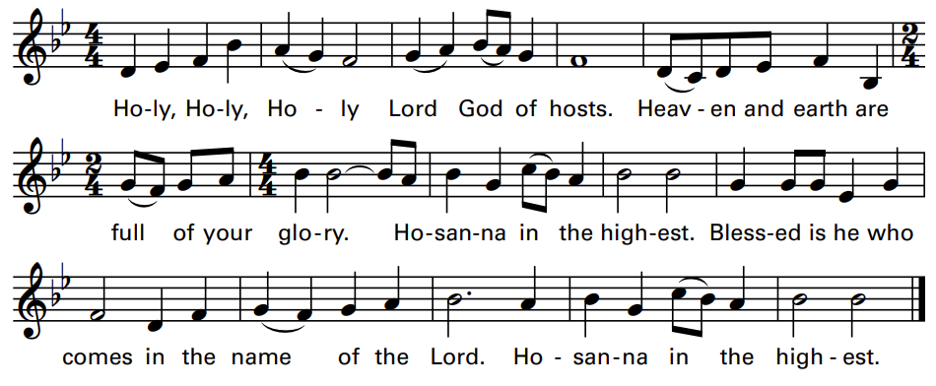

MEMORIAL ACCLAMATION:
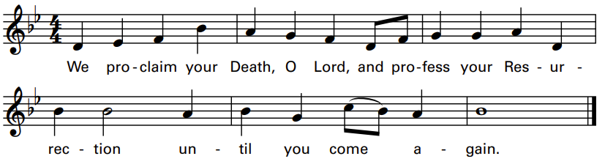

AMEN:
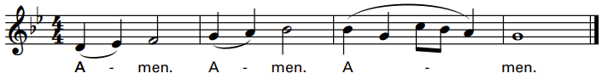
The Lord’s Prayer | Sign of Peace
LAMB of GOD:
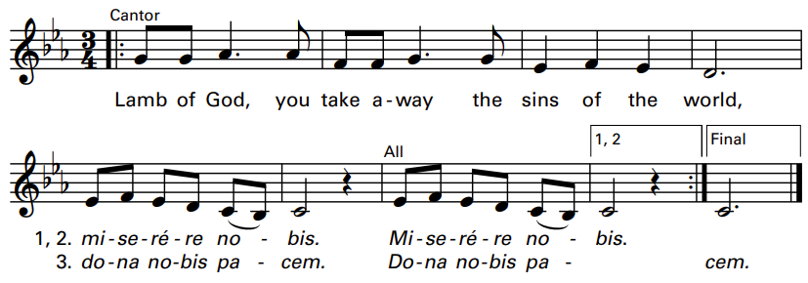

Music for the Communion Procession:

“Father, I Put My Life in Your Hands”

by John Michael Talbot

REFRAIN (CANTOR, then ALL):

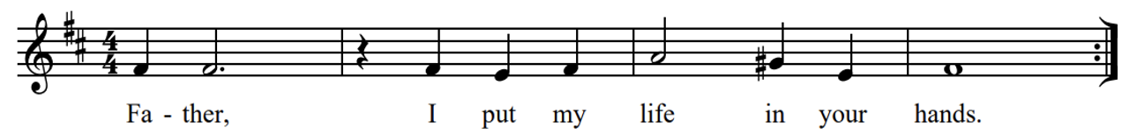
Recessional: “Our Father, We Have Wandered”

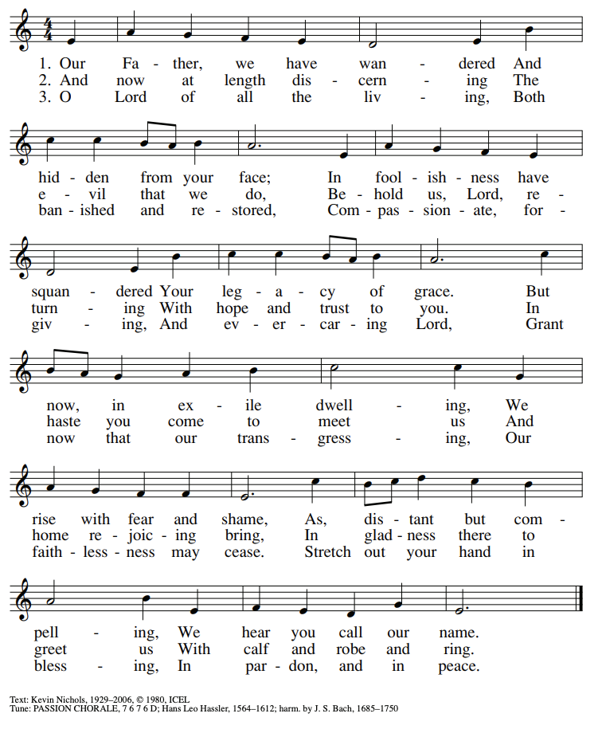

QR code for student registration

